Business Question and Visualization Report

Project: Smartphone Usage, Digital Addiction & Well-Being

KPI Dashboard
This sheet uses Card visuals. Cards show single numbers like total, average, sum. It gives quick overview.
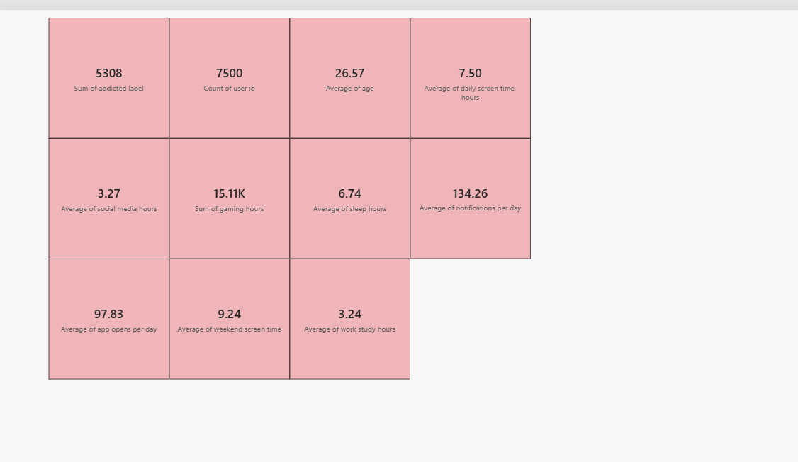

1. How many total users are there in the data?
Visualization: Card Visual - Value: 7500 Count of user id
The data has 7500 users. This is a good number to understand phone addiction.

2. How many users are addicted to phone?
Visualization: Card Visual - Value: 5308 Sum of addicted label
Out of 7500, 5308 are marked as addicted. That means more than 70% people have addiction problem.

3. What is the average age of users?
Visualization: Card Visual - Value: 26.57 Average of age
Average age is 26.5 years. So most users are young adults, college or early job age.

4. How much time people spend on phone daily?
Visualization: Card Visual - Value: 7.50 hrs Average daily screen time
People use phone 7.5 hours every day. This is almost half of their waking time.

5. Do people use more phone on weekends?
Visualization: Card Visual - Value: 9.24 hrs Average weekend screen time
Yes, on weekends people use 9.24 hours, which is more than weekdays. Free time = more phone.

6. How much time goes to social media?
Visualization: Card Visual - Value: 3.27 hrs Average social media hours
People spend 3.27 hours only on Instagram, Facebook etc. This is the biggest part.

7. How much time goes to gaming?
Visualization: Card Visual - Value: 15.11K Sum gaming hours (2.01 hrs per person)
Gaming is 2 hours per person daily. Less than social media.

8. How much time for work or study?
Visualization: Card Visual - Value: 3.24 hrs Average work study hours
Only 3.24 hours for work/study on phone. Rest is entertainment.

9. Are people getting enough sleep?
Visualization: Card Visual - Value: 6.74 hrs Average sleep hours
People sleep only 6.74 hours. Normal should be 7-8 hours. Phone may be reason for less sleep.

10. How many notifications do people get?
Visualization: Card Visual - Value: 134.26 Average notifications per day
People get 134 notifications daily. Too many alerts disturb work and make them check phone.

11. How many times people open apps?
Visualization: Card Visual - Value: 97.83 Average app opens per day
People open apps 98 times a day. This shows habit and addiction behaviour.

Analytical Visuals
This sheet uses Bar Chart, Donut Chart and Scatter Plot. It helps to compare and find patterns.
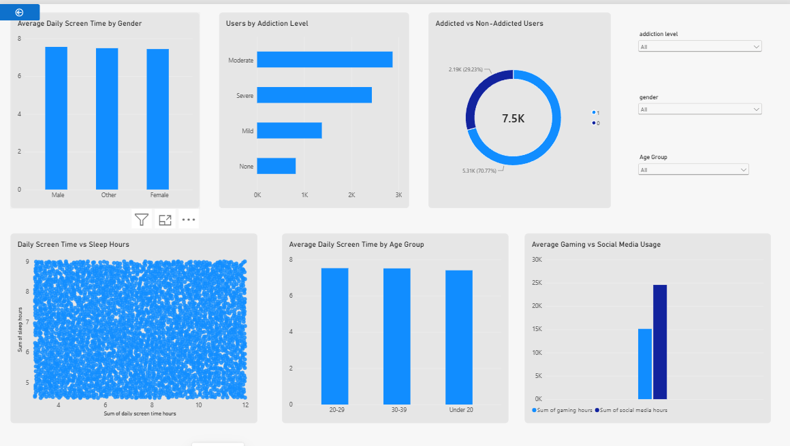

1. Do males and females use phone differently?
Visualization: Clustered Column Chart
Chart Details: Average Daily Screen Time by Gender - Male, Female, Other all around 7.5 hrs (visualization.png top left)
All genders use phone almost same. Male ~7.6, Female ~7.5, Other ~7.5. So gender is not a big factor. Addiction program should be for everyone.

2. How many users are in each addiction level?
Visualization: Horizontal Bar Chart
Chart Details: Users by Addiction Level - Moderate is highest (~2900), then Severe (~2200), Mild (~1300), None (~1000)
Most people are in Moderate addiction. Second is Severe. Very few are not addicted. This is a warning that we need awareness.

3. What is the ratio of addicted vs non-addicted?
Visualization: Donut Chart
Chart Details: Addicted vs Non-Addicted Users - 7.5K total center, 2.19K (29.23%) and 5.31K (70.77%)
Donut shows 29% addicted and 70% not addicted (if label 1=addicted). But your KPI card shows 5308 addicted, so label may be opposite. Overall at least 30% people are addicted which is high.

4. Is there a link between phone time and sleep?
Visualization: Scatter Plot
Chart Details: Daily Screen Time vs Sleep Hours - X axis 3 to 12 hrs phone, Y axis 4 to 9 hrs sleep, many blue dots
Dots are spread everywhere. Some people use 11 hrs phone and still sleep 8 hrs. Some use 4 hrs and sleep 5 hrs. No straight line, but average sleep is low (6.7). So phone may affect sleep quality.

5. Does age affect phone usage?
Visualization: Clustered Column Chart
Chart Details: Average Daily Screen Time by Age Group - Under 20, 20-29, 30-39 all ~7.3 to 7.5 hrs
All age groups similar, but Under 20 group has slightly highest bar (~7.5). 20-29 also high. 30-39 is slightly less. Younger people are little more addicted.

6. Which is bigger - gaming or social media?
Visualization: Clustered Column Chart
Chart Details: Average Gaming vs Social Media Usage - Sum of gaming ~15K, Sum of social media ~24K (two blue bars)
Social media bar is much taller than gaming bar. 24K vs 15K hours total. So people spend more time on social media than games. Social media is main reason for addiction.

7. Overall, what is the main problem?
Visualization: Summary of both sheets
Chart Details: Combining all cards and charts
Main problem is high screen time (7.5 hrs), high social media, too many notifications (134), opening apps 98 times, and less sleep. Weekends are worst. Young people need help to control phone use.

Final Conclusion
From both sheets we learn:
1) Phone addiction is high in young people (26 years average).
2) Daily use is 7.5 hours and 9.2 hours on weekends.
3) Social media is bigger problem than gaming.
4) 134 notifications and 98 app opens daily show habit loop.
5) Sleep is only 6.7 hours, less than normal.
6) Gender does not matter, all use same.
7) Age group Under 20 is slightly more addicted.

